**SOLANO COMMUNITY COLLEGE**

**MT 162, ROBOTICS**

Fall, 2018

SOLANO COMMUNITY COLLEGE

ROBOTIC SYSTEMS MT-162

**LAB 10: PICK-N-PLACE PROGRAMMING**

**Catharine Crayne**

11/16/18

**OBJECTIVE**:

1. To learn how to create a motion program that will pick and place objects.

**GROUP MEMBERS**

*Dianne Halsey, Jerry Livingston, Alex*

**MATERIALS**: RoboGuide and Laptop, Fanuc Robot w/gripper

**PROCEDURE**:

1. Power up the robot controller. Place the robot and pendant in Teach Mode.
2. Verify that the Gripper I/O is configured correctly (Probably RO[3] and RO[4])... They should work as complementary outputs.
3. Create a motion program that Pick up at least three items from one area of the table and place them in another area. The robot motion should clear an obstacle (an empty box) in between the pick and place motions.
4. Be sure to teach several points when picking and placing. Slow movements for when the robot is moving in to pick or place the part.
5. When the robot is picking a part, have the laser light on.
6. When the robot is carrying out the program, have the robot turn on the Yellow Light. When the cycle is complete, have the robot turn off the Yellow Light and turn on the Green Light.
7. What is the cycle time for your program?
8. BONUS. Create a program that performs a reverse motion path and moves the items back to their original location.

**RESULTS - DATA**

**Step 7:** 27.56 seconds

**OBSERVATIONS**

Step 2

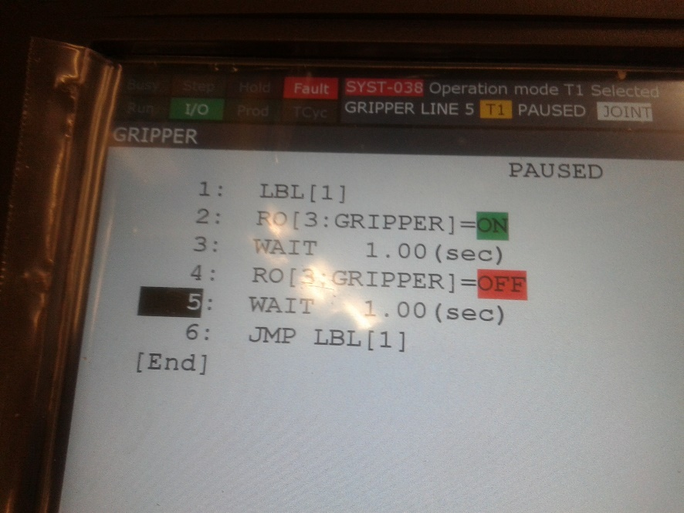

Step 3 - 5

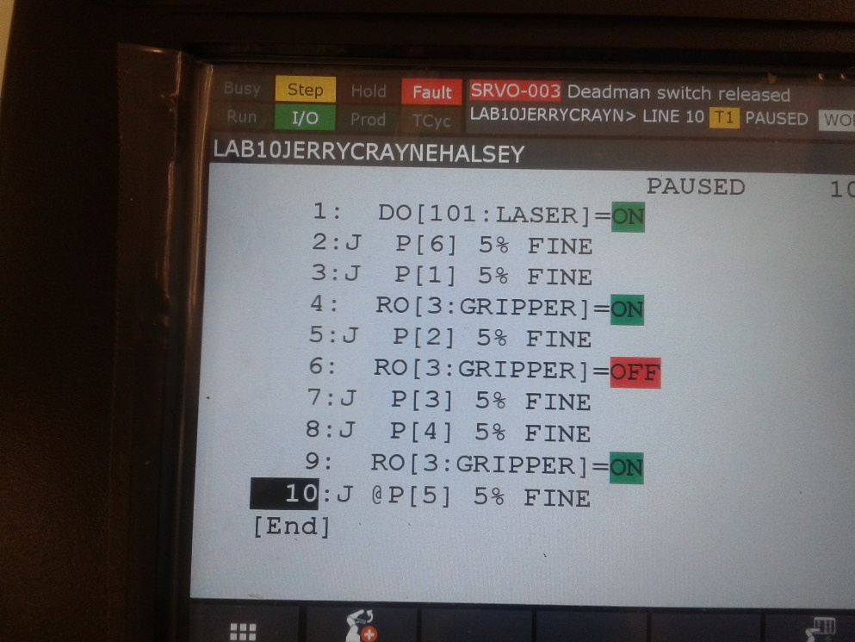 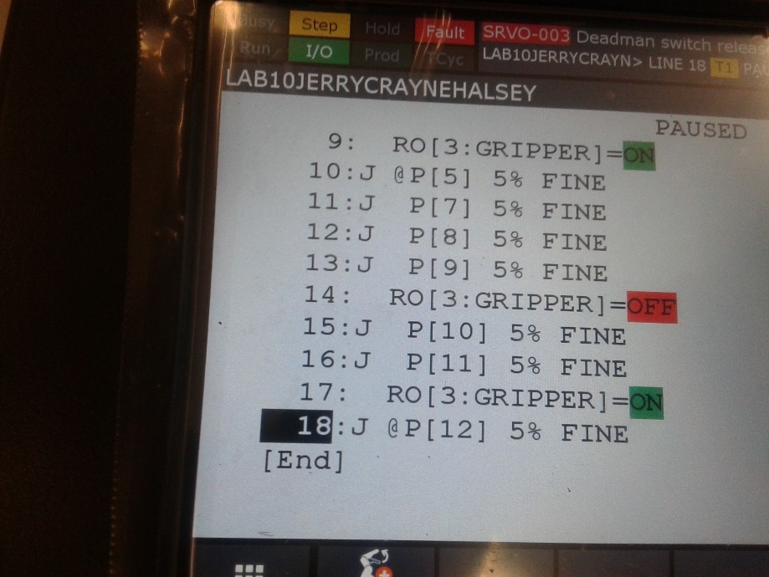

/PROG  LAB10JERRYCRAYNEHALSEY

/ATTR

OWNER        = MNEDITOR;

COMMENT        = "";

PROG_SIZE    = 1724;

CREATE        = DATE 18-11-08  TIME 20:01:28;

MODIFIED    = DATE 18-11-08  TIME 21:03:26;

FILE_NAME    = ;

VERSION        = 0;

LINE_COUNT    = 28;

MEMORY_SIZE    = 1984;

PROTECT        = READ_WRITE;

TCD:  STACK_SIZE    = 0,

     TASK_PRIORITY    = 50,

     TIME_SLICE    = 0,

     BUSY_LAMP_OFF    = 0,

     ABORT_REQUEST    = 0,

     PAUSE_REQUEST    = 0;

DEFAULT_GROUP    = 1,*,*,*,*;

CONTROL_CODE    = 00000000 00000000;

/MN

  1: DO[101]=ON ;

  2:J P[6] 5% FINE    ;

  3:J P[1] 5% FINE    ;

  4: RO[3]=ON ;

  5:J P[2] 5% FINE    ;

  6: RO[3]=OFF ;

  7:J P[3] 5% FINE    ;

  8:J P[4] 5% FINE    ;

  9: RO[3]=ON ;

 10:J P[5] 5% FINE    ;

 11:J P[7] 5% FINE    ;

 12:J P[8] 5% FINE    ;

 13:J P[9] 5% FINE    ;

 14:  RO[3]=OFF ;

 15:J P[10] 5% FINE    ;

 16:J P[11] 5% FINE    ;

 17:  RO[3]=ON ;

 18:J P[20] 5% FINE    ;

 19:J P[12] 5% FINE    ;

 20:J P[13] 5% FINE    ;

 21:J P[14] 5% FINE    ;

 22:J P[15] 5% FINE    ;

 23:  RO[3]=OFF ;

 24:J P[16] 5% FINE    ;

 25:J P[17] 5% FINE    ;

 26:J P[18] 5% FINE    ;

 27:  RO[3]=ON ;

 28:J P[19] 5% FINE    ;

/POS

P[1]{

  GP1:

    UF : 0, UT : 1,        CONFIG : 'N U T, 0, 0, 0',

    X =   400.677  mm,    Y =  -179.443  mm,    Z =  -200.165  mm,

    W =  -179.737 deg,    P =      .820 deg,    R =    -7.286 deg

};

P[2]{

  GP1:

    UF : 0, UT : 1,        CONFIG : 'N U T, 0, 0, 0',

    X =   400.676  mm,    Y =  -179.443  mm,    Z =  -224.285  mm,

    W =  -179.737 deg,    P =      .820 deg,    R =    -7.286 deg

};

P[3]{

  GP1:

    UF : 0, UT : 1,        CONFIG : 'N U T, 0, 0, 0',

    X =   400.676  mm,    Y =  -179.443  mm,    Z =  -145.084  mm,

    W =  -179.737 deg,    P =      .821 deg,    R =    -7.286 deg

};

P[4]{

  GP1:

    UF : 0, UT : 1,        CONFIG : 'N U T, 0, 0, 0',

    X =   400.676  mm,    Y =    64.637 mm,    Z =  -336.606  mm,

    W =  -179.737 deg,    P =      .821 deg,    R =    -7.286 deg

};

P[5]{

  GP1:

    UF : 0, UT : 1,        CONFIG : 'N U T, 0, 0, 0',

    X =   400.663  mm,    Y =    64.633 mm,    Z =  -108.738  mm,

    W =  -179.738 deg,    P =      .822 deg,    R =    -7.285 deg

};

P[6]{

  GP1:

    UF : 0, UT : 1,        CONFIG : 'N U T, 0, 0, 0',

    X =   402.837  mm,    Y =  -180.163  mm,    Z =   -10.084  mm,

    W =  -179.737 deg,    P =      .820 deg,    R =    -7.286 deg

};

P[7]{

  GP1:

    UF : 0, UT : 1,        CONFIG : 'N U T, 0, 0, 0',

    X =   394.902  mm,    Y =  -275.326  mm,    Z =  -116.669  mm,

    W =  -179.738 deg,    P =      .823 deg,    R =    -7.285 deg

};

P[8]{

  GP1:

    UF : 0, UT : 1,        CONFIG : 'N U T, 0, 0, 0',

    X =   399.462  mm,    Y =  -274.846  mm,    Z =  -199.469  mm,

    W =  -179.738 deg,    P =      .823 deg,    R =    -7.285 deg

};

P[9]{

  GP1:

    UF : 0, UT : 1,        CONFIG : 'N U T, 0, 0, 0',

    X =   399.462  mm,    Y =  -274.846  mm,    Z =  -226.350  mm,

    W =  -179.738 deg,    P =      .823 deg,    R =    -7.285 deg

};

P[10]{

  GP1:

    UF : 0, UT : 1,        CONFIG : 'N U T, 0, 0, 0',

    X =   399.463  mm,    Y =  -274.846  mm,    Z =   -60.750  mm,

    W =  -179.738 deg,    P =      .823 deg,    R =    -7.285 deg

};

P[11]{

  GP1:

    UF : 0, UT : 1,        CONFIG : 'N U T, 0, 0, 0',

    X =   407.269  mm,    Y =    45.535 mm,    Z =  -320.483  mm,

    W =  -179.678 deg,    P =      .642 deg,    R =    -7.280 deg

};

P[12]{

  GP1:

    UF : 0, UT : 1,        CONFIG : 'N U T, 0, 0, 0',

    X =   312.450  mm,    Y =  -333.391  mm,    Z =   -91.831  mm,

    W =  -179.732 deg,    P =      .835 deg,    R =    -7.285 deg

};

P[13]{

  GP1:

    UF : 0, UT : 1,        CONFIG : 'N U T, 0, 0, 0',

    X =   312.450  mm,    Y =  -333.391  mm,    Z =   -91.831  mm,

    W =  -179.732 deg,    P =      .835 deg,    R =    -7.285 deg

};

P[14]{

  GP1:

    UF : 0, UT : 1,        CONFIG : 'N U T, 0, 0, 0',

    X =   320.369  mm,    Y =  -332.671  mm,    Z =  -201.030  mm,

    W =  -179.732 deg,    P =      .835 deg,    R =    -7.285 deg

};

P[15]{

  GP1:

    UF : 0, UT : 1,        CONFIG : 'N U T, 0, 0, 0',

    X =   320.369  mm,    Y =  -332.671  mm,    Z =  -222.630  mm,

    W =  -179.732 deg,    P =      .835 deg,    R =    -7.285 deg

};

P[16]{

  GP1:

    UF : 0, UT : 1,        CONFIG : 'N U T, 0, 0, 0',

    X =   320.369  mm,    Y =  -332.671  mm,    Z =   -49.111  mm,

    W =  -179.732 deg,    P =      .835 deg,    R =    -7.285 deg

};

P[17]{

  GP1:

    UF : 0, UT : 1,        CONFIG : 'N U T, 0, 0, 0',

    X =   409.650  mm,    Y =    50.129 mm,    Z =   -50.071  mm,

    W =  -179.732 deg,    P =      .835 deg,    R =    -7.285 deg

};

P[18]{

  GP1:

    UF : 0, UT : 1,        CONFIG : 'N U T, 0, 0, 0',

    X =   426.690  mm,    Y =    65.249 mm,    Z =  -328.471  mm,

    W =  -178.839 deg,    P =      .949 deg,    R =    -7.271 deg

};

P[19]{

  GP1:

    UF : 0, UT : 1,        CONFIG : 'N U T, 0, 0, 0',

    X =   402.837  mm,    Y =  -180.163  mm,    Z =   -10.084  mm,

    W =  -179.737 deg,    P =      .820 deg,    R =    -7.286 deg

};

P[20]{

  GP1:

    UF : 0, UT : 1,        CONFIG : 'N U T, 0, 0, 0',

    X =   312.450  mm,    Y =     8.249 mm,    Z =   -84.631  mm,

    W =  -179.732 deg,    P =      .835 deg,    R =    -7.285 deg

};

/END

**Analysis Questions:**

1. How can the cycle time be increased in your program?

*Less points, minimize travel distance, increase speed.*

1. It is not uncommon for part picking operations to fail for some reason. What might cause these failures?

*The part that the robot is picking up is not in the correct coordinate position. Lack of air pressure to operate the gripper properly. Part is the incorrect size and cannot be picked up by the gripper (e.g. too large, too short). Power failure. An object that is not part of the programmed operations causes the safety sensor to engage and stop the robot.*

1. If the part picking does fail, what could be done so the robot knows it failed?

*The program can be altered so that it checks for certain conditions (sensor input) prior to executing each step in the program.*

1. What should be added to this motion program if the parts were a bit heavier?

*A Payload Schedule would need to be added to the program, either manually or in a program instruction. In order to set the Payload Instruction manually, the programmer should press [MENU] -> [SYSTEM] -> [TYPE] -> Motion, then press SETIND to activate the payload. You can then go to DETAIL to edit or change the Payload information. In a program, you place a call to the Payload Schedule you want.*